Project Design Phase-II
Data Flow Diagram & User Stories

Date | 12 July 2026
Team ID | PNT2026TMID_OPTICROP
Project Name | OptiCrop - Smart Agricultural Production Optimization Engine
Maximum Marks | 4 Marks

Data Flow Diagrams:
A Data Flow Diagram (DFD) is a traditional visual representation of the information flows within a system. A neat and clear DFD can depict the right amount of the system requirement graphically. It shows how data enters and leaves the system, what changes the information, and where data is stored.
Example: DFD Level 0 (Industry Standard)
Example: (Simplified)
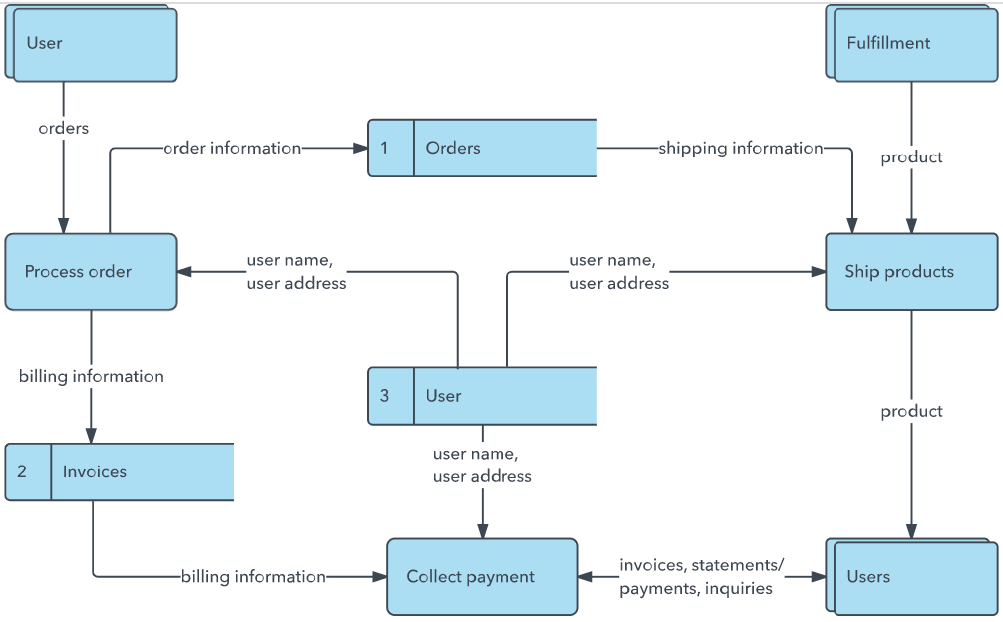


User Stories
Use the below template to list all the user stories for the product.
User Type | Functional Requirement (Epic) | User Story Number | User Story / Task | Acceptance criteria | Priority | Release
Farmer (End User) | Smart Crop Recommendation | USN-1 | As a farmer, I can enter my soil nutrients and climate readings so that I get the top-3 recommended crops for my land. | Given valid numeric inputs, the system returns 3 ranked crops with confidence percentages. | High | Release-1
 |  | USN-2 | As a farmer, I want to see a confidence score for each recommended crop so that I can judge how reliable the suggestion is. | Each of the top-3 crops shown has a numeric confidence % attached. | High | Release-1
 | Crop Suitability Check | USN-3 | As a farmer, I can select a specific crop and check how suitable my land is for it so that I can validate my own choice before planting. | Given a chosen crop and readings, the system shows an overall 0-100 score and a Highly/Moderately/Not Suitable verdict. | High | Release-1
 |  | USN-4 | As a farmer, I want a per-parameter breakdown (N, P, K, temp, humidity, pH, rainfall) so that I know exactly which factor is off. | Each parameter shows its value, the crop's ideal range, and a status tag (optimal/acceptable/unsuitable). | Medium | Release-1
Agricultural Officer / Researcher | Research & Policy Dashboard | USN-5 | As a researcher, I can view model accuracy and comparison metrics so that I can trust the recommendation engine. | Dashboard shows best model name, accuracy/F1 for all 5 algorithms tried. | Medium | Release-2
 |  | USN-6 | As a researcher, I can view per-crop parameter statistics and EDA charts so that I can study crop-environment relationships for planning. | Dashboard renders correlation heatmap, feature distribution and crop distribution charts. | Medium | Release-2
Student / Developer | Model Training | USN-7 | As a developer, I can regenerate the dataset and retrain the model with one command so that the app can be updated with new data. | Running train_model.py regenerates crop_model.pkl, scaler.pkl, metrics.json and chart images. | Low | Release-2
Customer Care Executive
Administrator

Our Data Flow Diagram — OptiCrop (Level 0)
